ARTIFICIAL INTELLIGENCE LAB
Task 3
Overestimating Heuristic Value
Course | CAI601400 - Artificial Intelligence Lab
Student Name | Uzair Alam
Roll Number | Su92-Bssem-S25-052
Submission Date | 24 October 2026
Submission To | Rasikh Ali
Prepared from the requirements in the Lab 4 manual

Contents
Overestimating Heuristic Value 3
What is happening in the code 3
Original 3
After Changing Heuristic Value 3
H(C) = 10 3
H(C) = 15 3

Overestimating Heuristic Value
If we overestimate heuritic value, A* can lose its guarantee of finding the best path. So lets check it if its real or not. In this task I changed one heuristic value, ran A* again, and checked if the result changes.

What is happening in the code
- The graph and the search function are the same as in Task 2.
- dict(givenHeuristic) makes a copy of the heuristic, so the original values stay safe.
- In the copy, only one value is changed, which is h(C). First it is set to 10 (the lab example), and then to 15.
- Each time, runSearch runs again with the changed values, and prints the path, the cost and the expanded nodes.
- The first two print lines show the original h(C) and the true remaining cost from C to G, so they can be compared.

Original
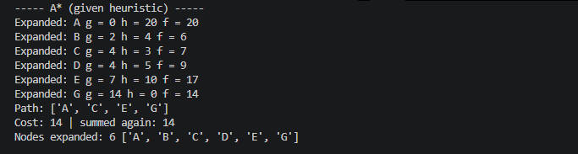

After Changing Heuristic Value

H(C) = 10
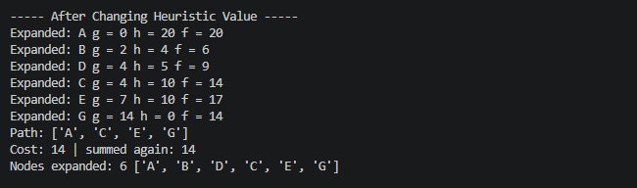

H(C) = 15

